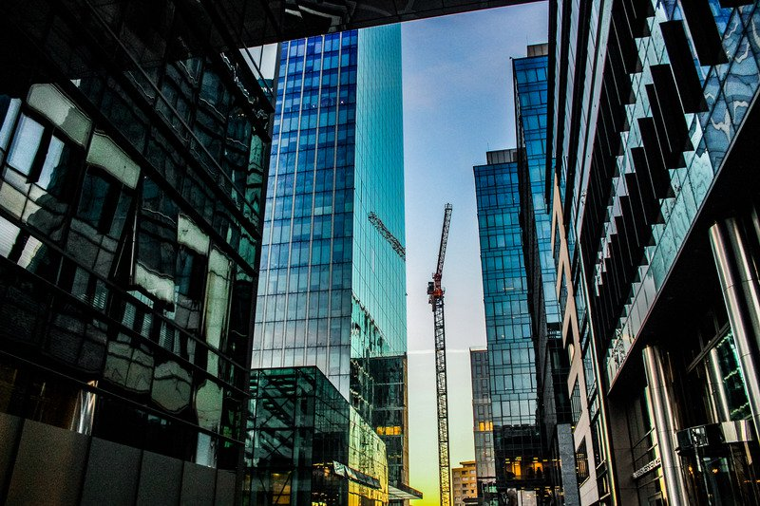  June 18, 2019  Why Smart buildings?  Leveraging Smart Tech for Building Performance  Join the Smart Buildings Center and the Building Commissioning Association for a one day conference on June 18th, 2019 at the Pacific Tower in Seattle, WA. The conference, aimed at commercial building owners and managers, building operations and engineering staff, commissioning agents, architects, engineers, and property developers, offers opportunities to gain knowledge, connections and success regarding building performance through smart technologies and practices.  Attendees will learn how smart technologies and practices improve building performance, increase tenant and occupant productivity, enhance security, and provide sustained operational cost savings. Hear about real world examples of smart technology applications and practices from building professionals in the industry. Conference sessions will focus on IoT (Internet of Things) for building performance, what tools people are using to increase building performance, and what the industry is doing with these advances in technology.  Register at www.whysmartbuildingsjune18.eventbrite.com  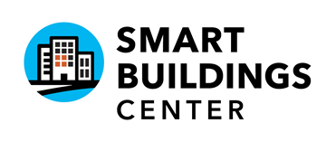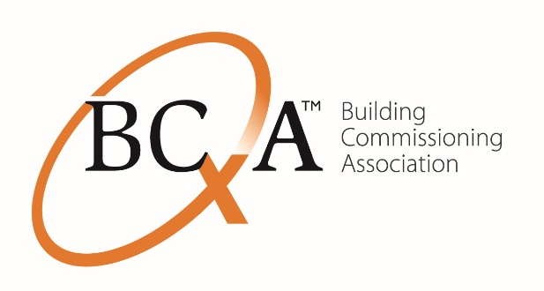 | June 18th, 2019  8:30am – 4pm  ────  Pacific Tower  Panoramic Room - 8th Floor  1200 12th Ave S.  Seattle, WA 98144  ────  Registration: $ 35 Continental Breakfast &  Lunch Included  ────  Questions? Contact events@smartbuildingscenter.org

